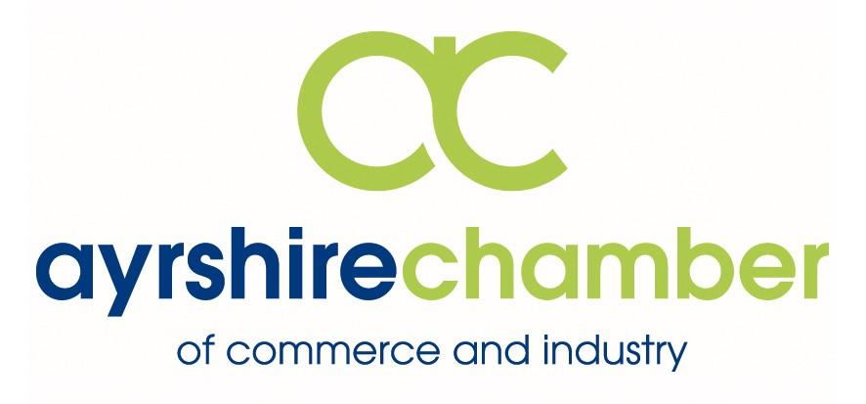

Ayrshire Chamber Annual General Meeting

Thursday 27th September 2018 at 15.30

The Gailes Hotel, Irvine

Agenda

Registration, tea and coffee

Welcome and Introductions

Annual General Meeting

Networking with buffet & refreshments

Finish

Partners for Business:
1825 Financial Planning, Andrew Wright Glass, Andrew Wright Windows, Ayrshire College, Barclays, Barr, Frazer Coogans Commercial Solicitors, Halo Communications Ltd, Hillhouse Quarry Group Ltd ,Ingram Motoring Group Launch, Lighthouse IT & Network Solutions, Mackay Corporate Insurance Brokers, Media Scotland, Neogen Europe Ltd, QTS Training, SP Energy Networks, Westfield Health, West FM, William Duncan & Co,

