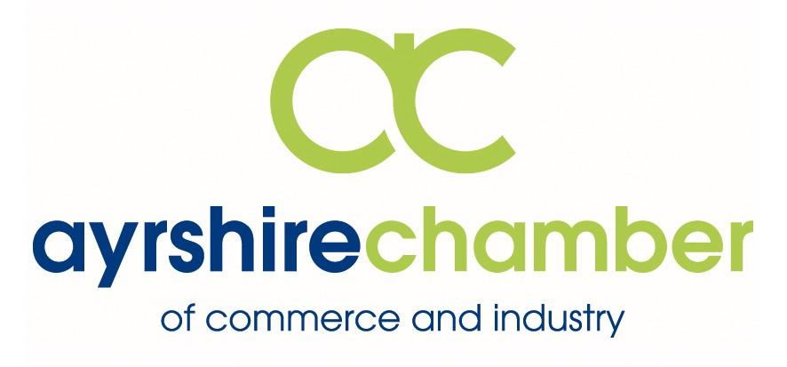

Ayrshire Chamber Annual General Meeting

Thursday 14nd September 2017 at 15.00

The Carlton, Prestwick

Agenda

Registration, tea and coffee

Welcome and Introductions

Annual General Meeting

Ayrshire Growth Deal Presentation
Patrick Wiggins

Networking

Finish

Partners for Business:
Ayrshire College, Bank of Scotland, Barr, Frazer Coogans Commercial Solicitors, Halo Communications Ltd, Hillhouse Quarry Group Ltd ,Ingram Motoring Group Launch, Lighthouse IT & Network Solutions, Mackay Corporate Insurance Brokers, Neogen Europe Ltd, 1825 Financial Planning, QTS Training, SP Energy Networks, Trump Turnberry Scotland, VOCA, Westfield Health, West FM, William Duncan & Co,

